# Chapter I

### Introduction of the Industry

#### Introduction to the Industry :

* Overview –

Incorporated on 16 January 2018, Reknot Solutions (Pvt) Ltd is non-govt. and a leading development & design expert company providing quality products and services to companies globally. I joined Reknot Solutions (Pvt) Ltd as a Web Application Developer. Having a strong Technology Development and Innovation centre in Thane, Maharashtra and with more than 25+ satisfied clients, ranging from start-ups - fortune 500 companies across diverse industries, Reknot Solutions has made its mark as a well-established and sound company driven by the industry's highly professional and trained individuals and is surely headed in becoming a leading organization which facilitates, enhances and provides measurable business value to customers through most effective uses of technology and Resources to organizations globally. It is involved in other computer related activities [for example maintenance of websites of other firms/ creation of multimedia presentations for other firms etc.].

* The Objectives of Reknot Solutions Private Limited:
* Standardize and codify key software project concepts and terminology.
* Ensure business goals and objectives are considered at all stages of a project.
* Develop an accurate and flexible model describing key project activities.
* Identify and leverage accurate insights into software project success and failure rates and reasons.
* Identify and encourage best practices which are appropriate for a particular project.
* Develop software project activity accelerators.
* Develop software project risk-reducers. Encourage a spirit of openness, transparency, integrity, trust, and continuous learning. Build and nurture a global community that shares our vision and mission Provably and reliably reduce the cost, effort, duration and risk of software projects.

# Chapter II

### Organizational Structure

#### Organizational Structure :

Trainees

UI / UX Design Team

Web Development Team

Android Development Team

Directors

Sales

Manager

An organizational structure is a system that outlines how certain activities are directed in order to achieve the goals of an organization. These activities can include rules, roles, and responsibilities. The organizational structure also determines how information flows between levels within the company.

When an organization has clear company policies, both employees and employers benefit.

Outlining employees’ rights and expectations within your company helps set behavioral

and performance standards for the workplace, and gives employees an overall framework of how to be successful at your company.

* + Policies at Reknot Solutions -

1. Manpower planning policy:

To ensure a right number of people with right skills at right place at right time to implement organizational strategies in order to achieve organizational objectives. Ensuring Human Resource supply meets Human Resource demands.

1. Recruitment & Selection Policy:

To identify and recruit team members with the knowledge, skills and aptitude required for the identified positions.

1. Employment Terms & Conditions Policy:

To provide clear and transparent terms and conditions of employment which are in tandem with all legal requirement.

1. Induction & Orientation Policy:

To orient and align the new joined team member to the products, process and procedures in the organization & induct the new joined team members with the work environment of organization. Help them clarify any doubts about the working & job profile. Induction is a systematic and formal procedure for integrating a new team member into the organization. It aims at giving all the relevant information to the new team member and making him adjust comfortably in the new environment of the organization.

1. Performance Management Policy:

Appraisal is a tool to define the performance level of each team member and it should be monitored regularly. Formal Review should be at least quarterly. Eventually it is the sum total of team member's performance, which decides the performance of the organization. From organization's point of view, each team member has a cost and in return he / she is expected to contribute towards achieving departmental / organizational targets. Through appraisal, we set individual targets (KRAS – PQCDSM Targets) and finally evaluate individual performance against these mutually agreed criteria. From team member point of view, it is important that clear targets/goals are decided so that he/she can make action plans, if needed demand resources. Whereas money is considered to be the biggest motivator, but this alone cannot infuse enthusiasm in team member to give his/her best. Clear target and regular feedback on performance can keep team member charged. With structured appraisal system we can ensure timely and fair increments of the team members working in the company based on their performance. Acknowledge the individual's performance and reward accordingly to boost their morale and motivate them.

1. Training and Development Policy:

To evaluate and improve team member’s knowledge, skills and attitude and to facilitate their overall development through training process, helping team members to enhance their competence in a planned and systematic manner. Through training process, the skills of the team members are to be continuously updated in tune with the requirements.

Through training fill the gap between the present level of performance and the expected level of performance. To encourage team members to recognize, develop and use their skills and abilities

# Chapter III

### Learning Resources Collected

#### Learning Resources used during Inplant Training:

During this Inplant training, I had learnt about various subjects and used platforms like Bootstrap, Git, GitHub, Laravel Framework, AdminLTE through different books, websites and reference material provided by industry. Articles and official documentation helped in learning platforms and new technology as self-paced and very convieniently.

Some screenshots of diagrammatic and pictorial representation of concepts that I have learnt in my internship are given below :

* + Bootstrap

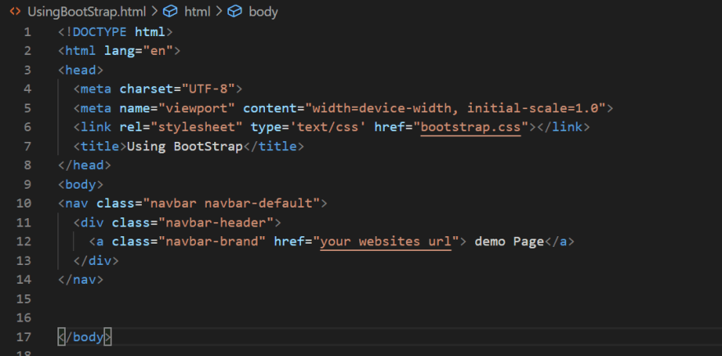

* + Git commands

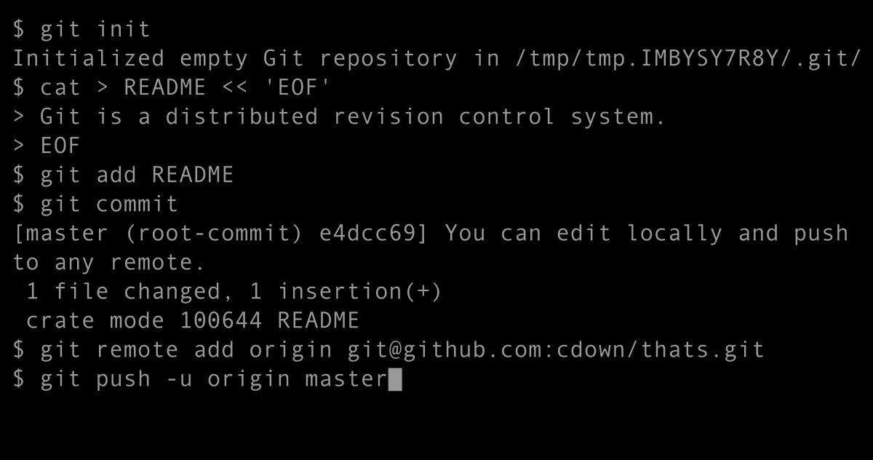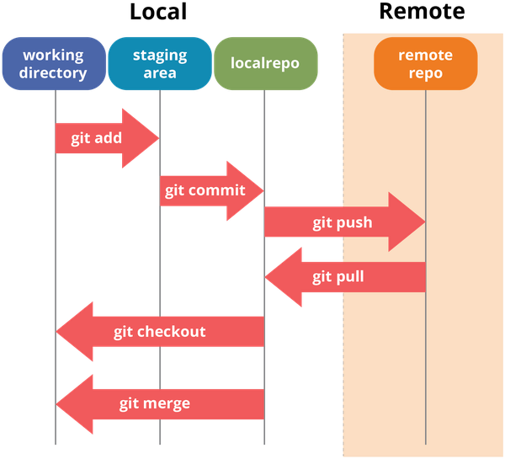

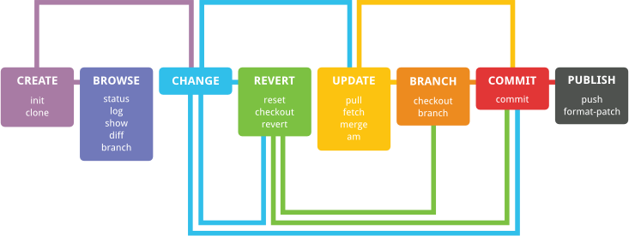

* + GitHub

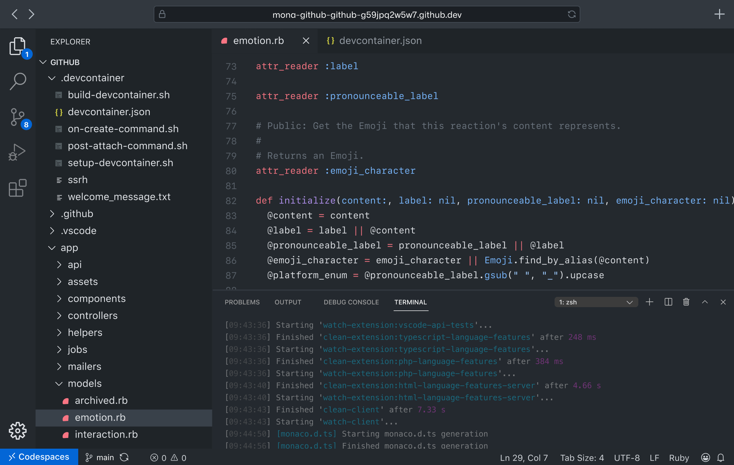

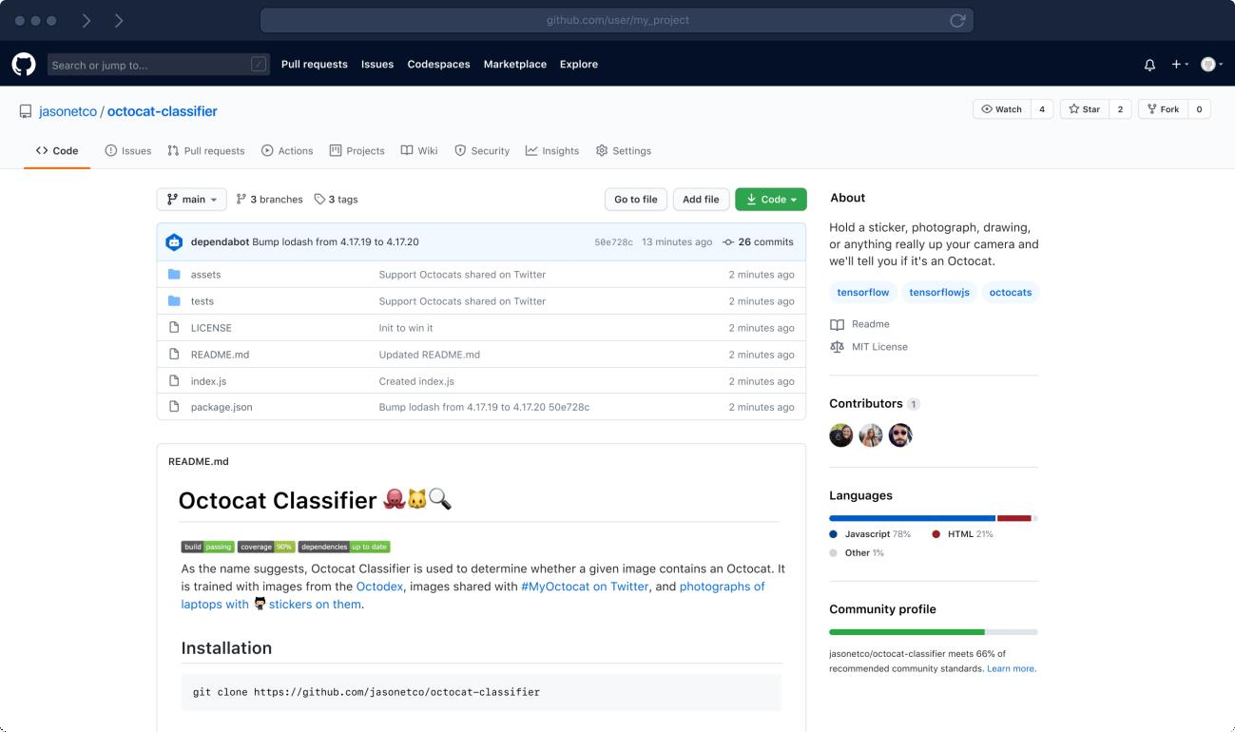

* + XAMPP

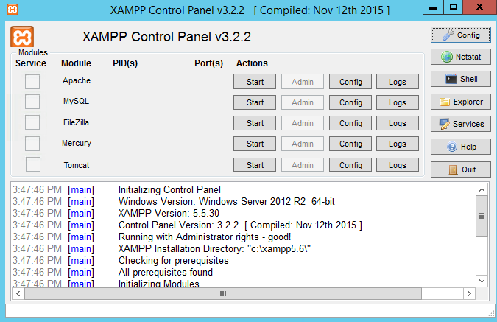

* + Laravel Framework

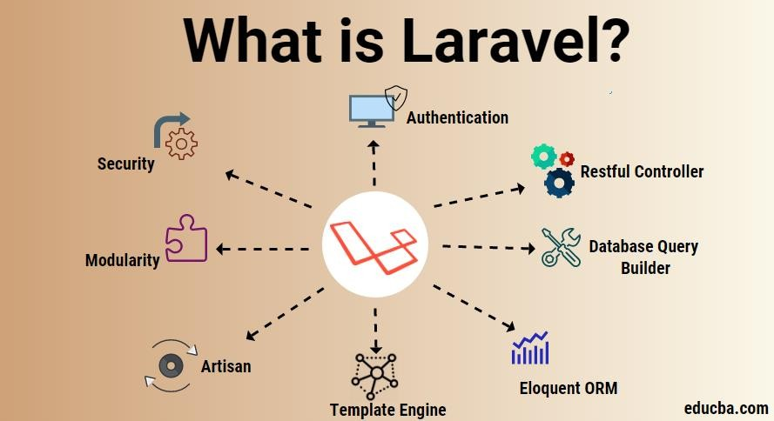

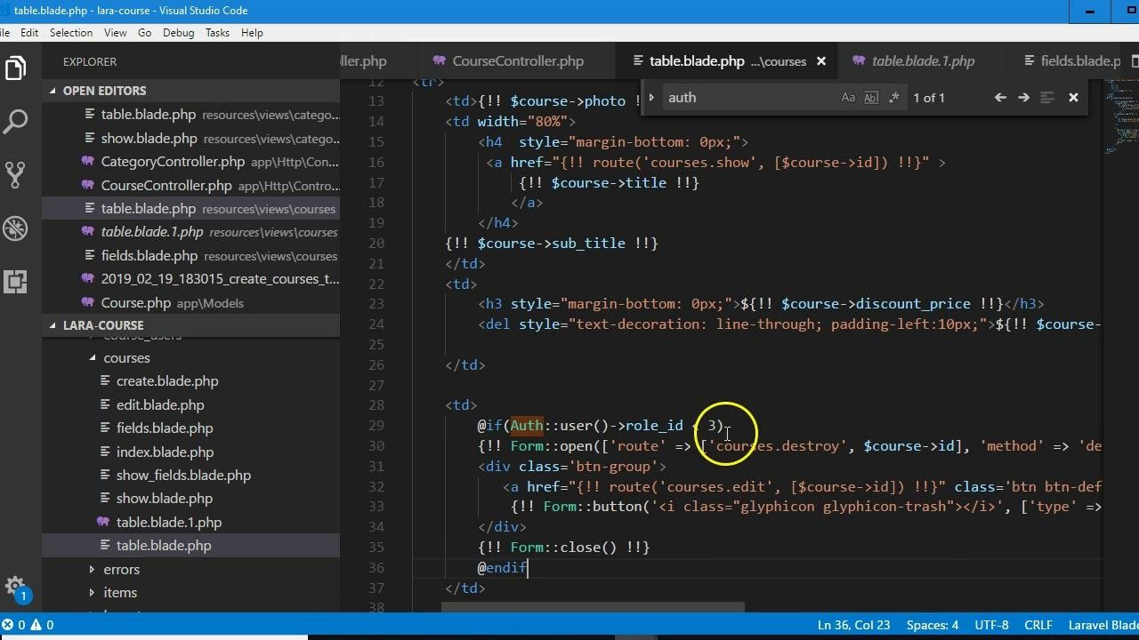

* + AdminLTE

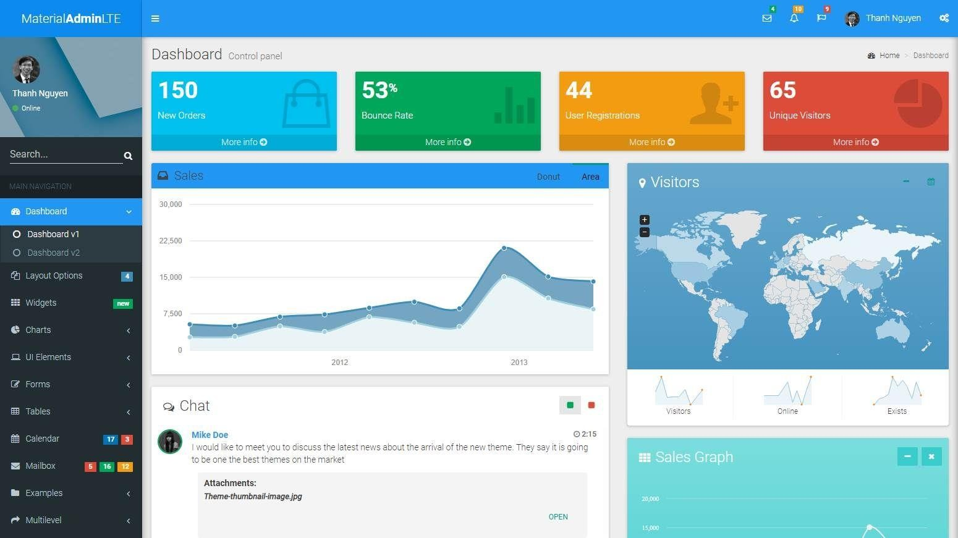

# Chapter IV

Detail Report on Work Done

GOVERNMENT POLYTECHNIC, MUMBAI

#### 49, Kherwadi, Ali Yawar Jung Marg, Bandra (E), Mumbai-51

Weekly Report of Inplant Training

Name of the student : Sahil Manohar Raut Enrollment No : FS19IF010

Programme : Information Technology Dept/Plant/Section :

Company name & address : 1st Floor, Room No. 13, Panch Pandav Bldg, Road No. 16, Kisan Nagar, Wagle Estate, Thane, Mumbai – 400604.

|  |  |  |  |
| --- | --- | --- | --- |
| Week No. | Date | Brief report of work done | Attendance No. of days |
| 1. | 03 / 03 / 2022 to  18 / 03 / 2022 | Initial few weeks at Reknot Solutions Pvt. Ltd were of an introductory weeks. They introduced us to the company and gave a briefing on how the company works, its policies, functioning, work culture, corporate  world, etc | Present = 12  Absent = 00  Leave = 00 |
| 2. | 21 / 03 /2022 to  01 / 04 / 2022 | In continuation, I was assigned the task by industry mentor of creating E- profile using bootstrap. For structuring of page, I used HTML5 and CSS3 for designing purpose. I used Bootstrap Framework as per requirement, so that we can develop good-looking and responsive web- pages which are supported by all kinds of browsers. | Present = 10  Absent = 00  Leave = 00 |

## GOVERNMENT POLYTECHNIC, MUMBAI

#### 49, Kherwadi, Ali Yawar Jung Marg, Bandra (E), Mumbai-51

Weekly Report of Inplant Training

Name of the student : Sahil Manohar Raut Enrollment No : FS19IF010

Programme : Information Technology Dept/Plant/Section :

Company name & address : 1st Floor, Room No. 13, Panch Pandav Bldg, Road No. 16, Kisan Nagar, Wagle Estate, Thane, Mumbai – 400604.

|  |  |  |  |
| --- | --- | --- | --- |
| Week No. | Date | Brief report of work done | Attendance No. of days |
| 3. | 04 / 04 / 2022 to  19 / 04 / 2022 | In later weeks, I was told to learn Git & GitHub and learnt some functions like initializing repository, adding files to staged state, committing repository, publishing it to GitHub, creating and merging branches and  also used pull and push functions. | Present = 12  Absent = 00  Leave = 00 |
| 4. | 20 / 04 / 2022 to  03 / 05 / 2022 | After some period and doing individual tasks, Mentor introduced us and gave a briefing about a project called Influencer. It is an app where famous and great personalities set to connect and interact with their fans and followers. For this project, 3 teams namely Android, Web and UI/UX teams were created and assigned  with certain tasks and targets. | Present = 12  Absent = 00  Leave = 00 |

## GOVERNMENT POLYTECHNIC, MUMBAI

#### 49, Kherwadi, Ali Yawar Jung Marg, Bandra (E), Mumbai-51

Weekly Report of Inplant Training

Name of the student : Sahil Manohar Raut Enrollment No : FS19IF010

Programme : Information Technology Dept/Plant/Section :

Company name & address : 1st Floor, Room No. 13, Panch Pandav Bldg, Road No. 16, Kisan Nagar, Wagle Estate, Thane, Mumbai – 400604.

|  |  |  |  |
| --- | --- | --- | --- |
| Week No. | Date | Brief report of work done | Attendance No. of days |
| 5. | 09 / 05 / 2022 to  23 / 05 / 2022 | After the project planning session, I was assigned a responsibility in Web Application Team where we were initially told to learn and get hands on with XAMPP server and to create SQL queries for  database. | Present = 11  Absent = 00  Leave = 00 |
| 6. | 24 / 05 / 2022 to  07 / 06 / 2022 | In this duration, I was told to work on creating CRUD forms using PHP and Laravel framework.  Throughout this task I got a chance to learn the basics of Laravel framework and also made CRUD forms to manage data of the project and for database purpose XAMPP server was used. | Present = 13  Absent = 00  Leave = 00 |

Students Signature :

Dated Signature of Industry Mentor : Dated Signature of Polytechnic Mentor:

# Chapter V Conclusion

#### Conclusion :

After 4 months at Reknot Soultions, my time as an intern is coming to an end. The skills I have gained and the knowledge I am taking away are immeasurable. I could not have asked for a better first internship experience to build a foundation for my career. This experience of Inplant Training gave me the opportunity to test my knowledge and skills that I learned during the Diploma course.

This experience taught me about the corporate functioning of the industry. The Inplant Training helped me in gaining experience of the corporate world and helped me in growing in aspects of professionalism. The Inplant Training helped to enhance my communication skills. I also gained the knowledge of Web Development in depth during my Inplant Training. At times I worked and communicated through formal platforms. I took part in development meetings to understand more about the development process followed within the industry.

During Inplant Training, I got the opportunity to meet people with different educational backgrounds as well as people with different experiences in the IT industry. I learned from them about the new technologies and their implementation during the Inplant Training. This training period provided me an opportunity to work on various different technologies and learn about them. I worked as Software developer on Web application team and learned about various aspects of the fields and various tools and software used in the industry for web application process. I also learned to use platforms such as Git, GitHub, Laravel Framework and learned about the development cycles followed within the industry. This experience helped me grow and develop my skills.

# Chapter VI

### References

#### References :

<https://www.youtube.com/watch?v=c9B4TPnak1A>

[https://infyspringboard.onwingspan.com/web/en/app/toc/lex_10096720378773369000_share](https://infyspringboard.onwingspan.com/web/en/app/toc/lex_10096720378773369000_shared/overview) [d/overview](https://infyspringboard.onwingspan.com/web/en/app/toc/lex_10096720378773369000_shared/overview)

<https://www.youtube.com/watch?v=RGOj5yH7evk>

[https://infyspringboard.onwingspan.com/web/en/app/toc/lex_auth_013294654145536000208](https://infyspringboard.onwingspan.com/web/en/app/toc/lex_auth_01329465414553600020891_shared/overview) [91_shared/overview](https://infyspringboard.onwingspan.com/web/en/app/toc/lex_auth_01329465414553600020891_shared/overview)

[https://infyspringboard.onwingspan.com/web/en/app/toc/lex_auth_013303925793439744326](https://infyspringboard.onwingspan.com/web/en/app/toc/lex_auth_01330392579343974432658_shared/overview) [58_shared/overview](https://infyspringboard.onwingspan.com/web/en/app/toc/lex_auth_01330392579343974432658_shared/overview)

[https://www.youtube.com/watch?v=0yVDMcGp97g&list=PLjVLYmrlmjGfh2rwJjrmKNHzGxCZwB](https://www.youtube.com/watch?v=0yVDMcGp97g&list=PLjVLYmrlmjGfh2rwJjrmKNHzGxCZwBsqj) [sqj](https://www.youtube.com/watch?v=0yVDMcGp97g&list=PLjVLYmrlmjGfh2rwJjrmKNHzGxCZwBsqj)

[https://infyspringboard.onwingspan.com/web/en/app/toc/lex_auth_013094425513320448207](https://infyspringboard.onwingspan.com/web/en/app/toc/lex_auth_0130944255133204482079_shared/overview) [9_shared/overview](https://infyspringboard.onwingspan.com/web/en/app/toc/lex_auth_0130944255133204482079_shared/overview)

[https://infyspringboard.onwingspan.com/web/en/app/toc/lex_auth_01317717220340531299_](https://infyspringboard.onwingspan.com/web/en/app/toc/lex_auth_01317717220340531299_shared/overview) [shared/overview](https://infyspringboard.onwingspan.com/web/en/app/toc/lex_auth_01317717220340531299_shared/overview)

<https://www.youtube.com/watch?v=nubhLO0SXXA>

<https://adminlte.io/docs/3.2/>